# User Interface Wireframes

### Login screen:

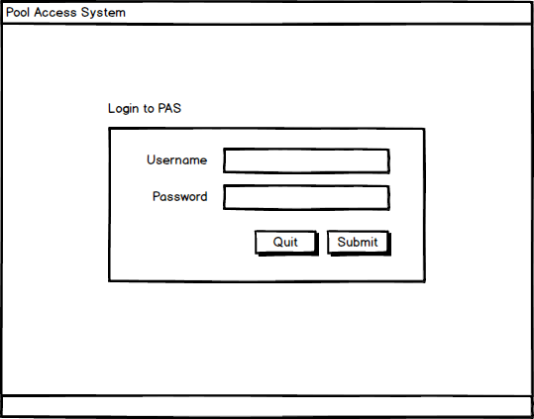

The Login Screen is used to verify users with username and password credentials. Successful verification will open the main program, defaulting to the Find Swimmer screen. Unsuccessful authentication will display an error message at the bottom of the screen

Instructions:

* Type username and password into the respective fields
* Click submit to authenticate username and password

### Find Swimmer screen:

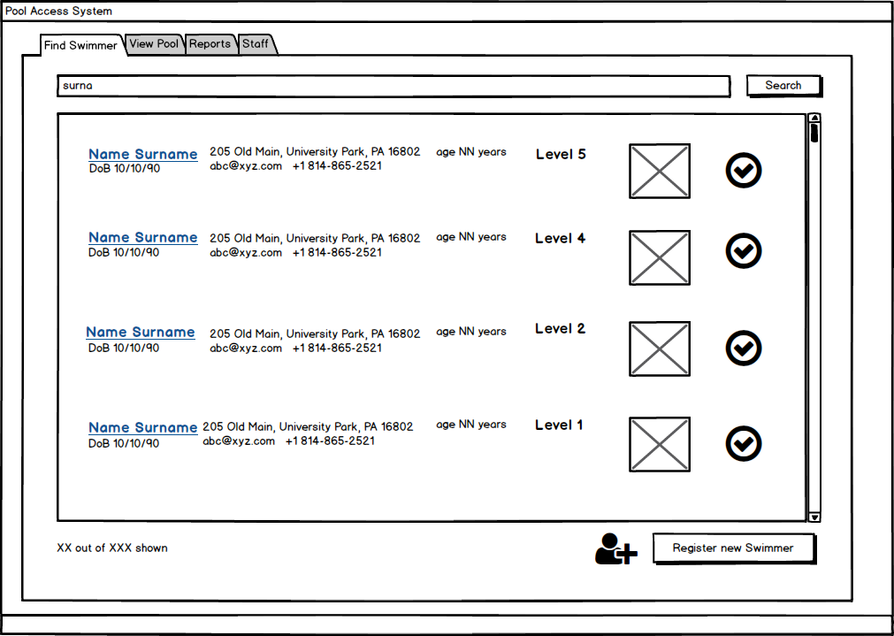

The Find Swimmer screen displays a list of all swimmers currently registered to the system along with their general information and picture. The user can refine the list by searching for the swimmer’s name or key words in the swimmer’s general information. If the user is a manger, they can edit the swimmer’s profile or register a new swimmer. The user can also check-in and check-out swimmers.

Instructions:

* Search by Name or Key Word
  + Type a name or key word as it would appear on the screen (i.e. phone numbers must be entered as XXX-XXX-XXXX) into the search field and click the search button. The screen will display matching results or an error message.
* Edit Profile
  + Click the ‘Edit’ button with in the row of the swimmer to be edited
* Check-In/Check-Out Swimmer
  + Click the check-in or check-out button within the row of the swimmer to be checked into or out of the pool. The buttons will alternate in active status to reflect whether a swimmer is in or out of the pool.
* View Full Profile
  + Clicking on the swimmer’s name will redirect the user to the swimmer’s profile, where they are able to view more detailed information and edit if permitted.
* Navigate to another use case
  + Click on the tab on the top of the screen that corresponds to the desired use case

### Register new Swimmer:

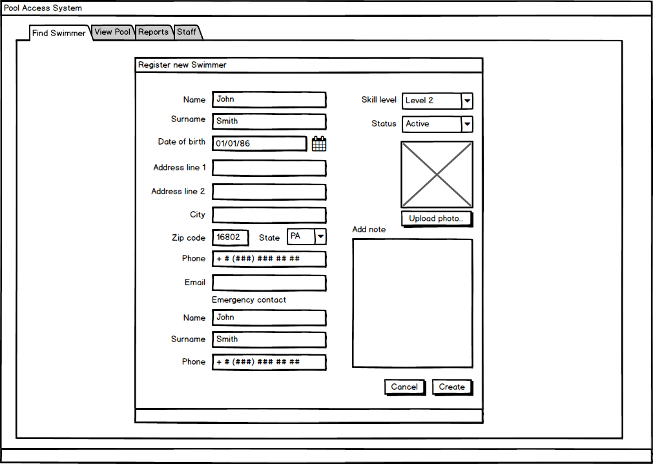

Register new swimmer allows the user to create an entirely new swimmer by filling out personally identifiable information which can later be used to search by in the “Find Swimmer” screen. The “skill level” dropdown corresponds to the swimmer’s swimming skill which relates to how much focus should be placed on this swimmer by the lifeguards. The Status dropdown refers to whether or not the swimmer is banned, suspended, or active in regards to accessing the pool. This defaults to Active, but can be changed depending on the situation. The user can upload a photo for the swimmer by clicking the Upload Photo button, which opens a standard directory explorer where they can select the appropriate file.

* Navigate to another use case
  + Click on the tab on the top of the screen that corresponds to the desired use case

### Update Swimmer:

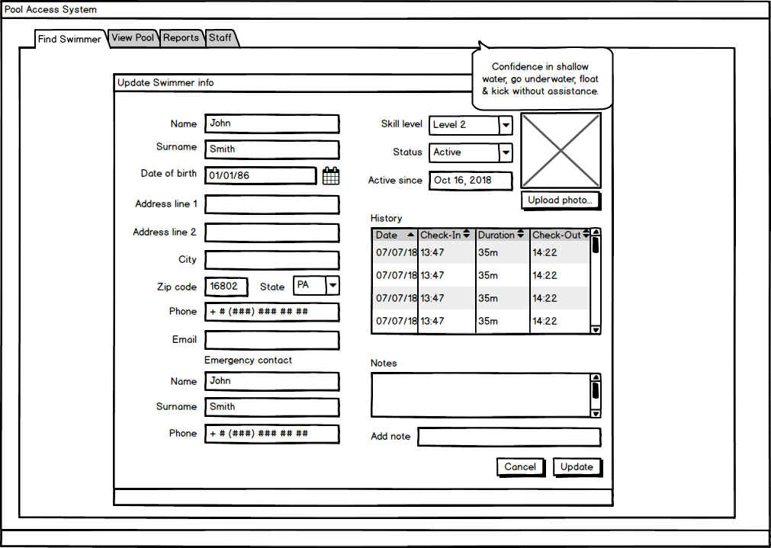

Similar to “Register New Swimmer”, “Update Swimmer” allows the user to edit the specific swimmer’s information. This screen also acts as the View Profile screen, as it not only has the same fields (but editable) as the “Register New Swimmer”, but the user can also view the customer’s visit history.

* Navigate to another use case
  + Click on the tab on the top of the screen that corresponds to the desired use case

### View Pool screen:

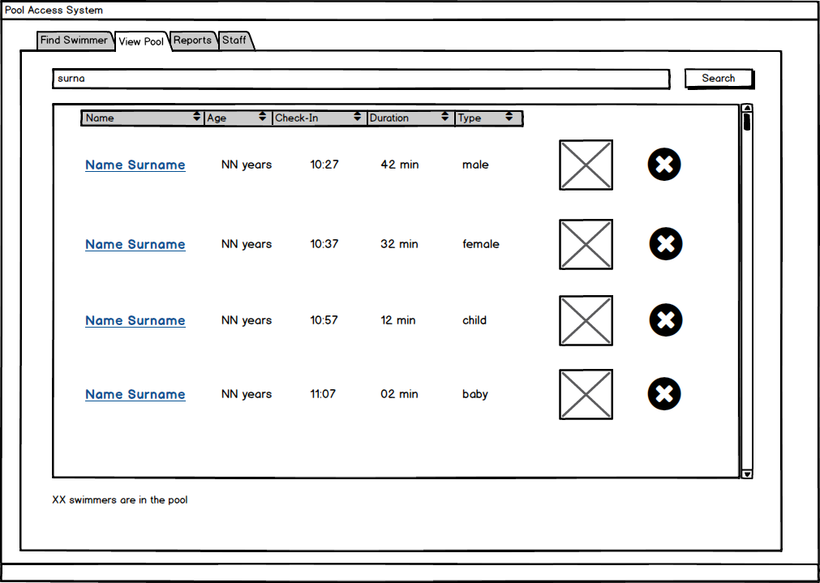

The View Pool Screen displays a list of swimmers currently checked in and active at the pool along with the swimmers’ age, check-in time, duration spent at the pool, type (male, female, child, baby), and picture. The list can be further refined by name or sorted. The user may access a swimmer’s full profile information or check swimmers out of the pool.

Instructions:

* Search by Name
  + Type a first or last name into the search field and click the search button. The screen will display matching results or an error message.
* Toggle order by Name, Age, Check-In Time, Duration at the Pool, or Type
  + Click the respective category in the title bar to sort the list accordingly, an additional click will reverse the order
* Check-out Swimmer
  + Click the ‘X’ on the row of the swimmer to be checked-out. The swimmer will be removed from the list.
* View a Swimmer Profile
  + Click the underlined name of the swimmer.
* Navigate to another use case
  + Click on the tab on the top of the screen that corresponds to the desired use case

### Reports/View Visits screen:

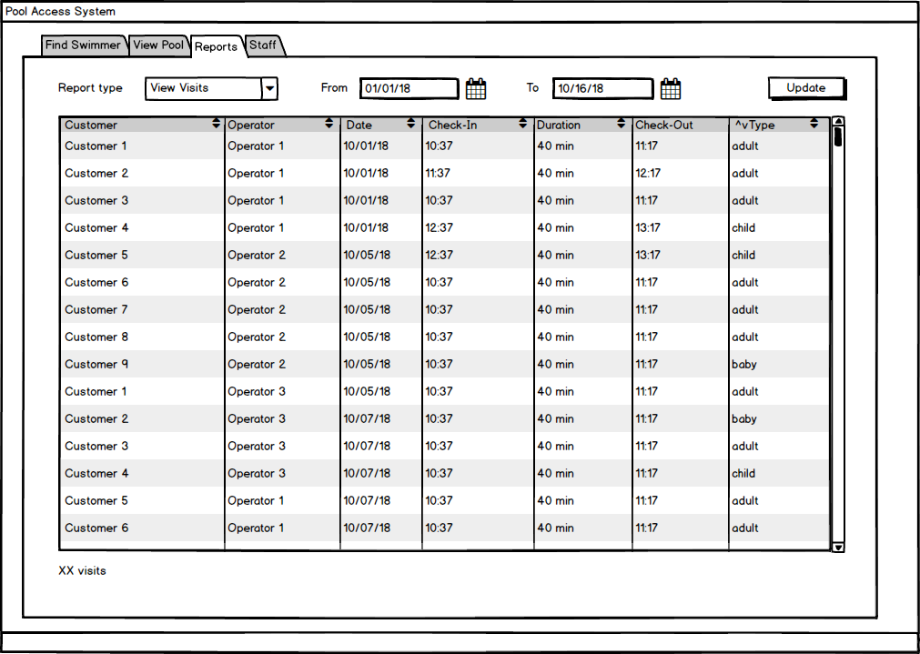

### Reports/View Customers screen:

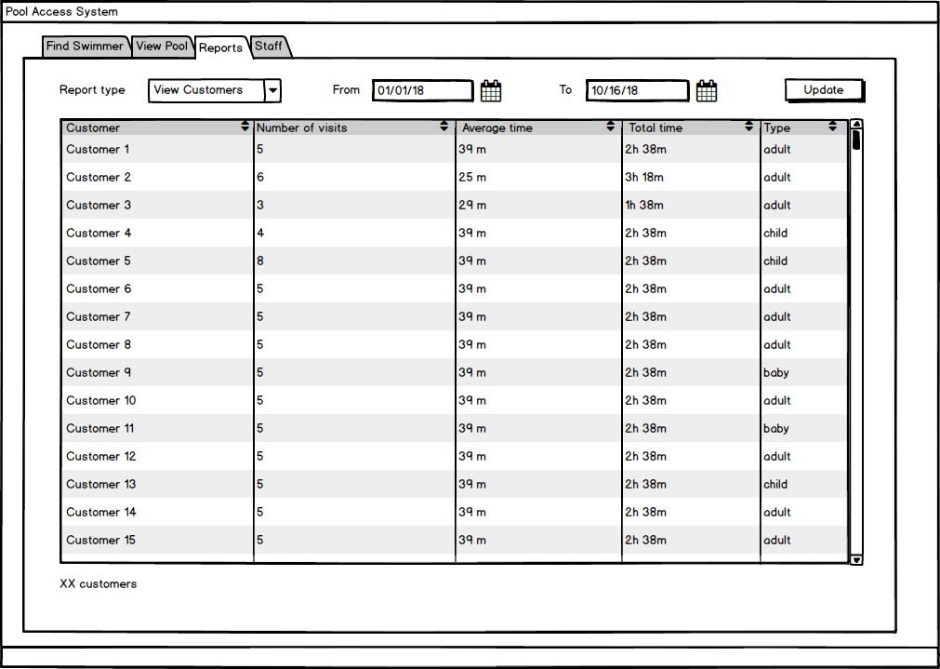

### Reports/Attendance screen:

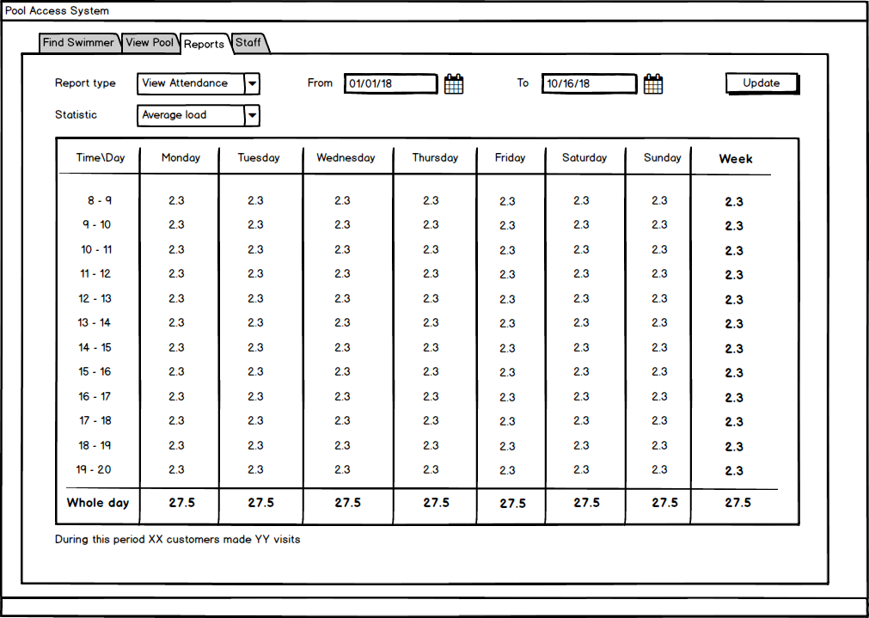

### Staff screen:

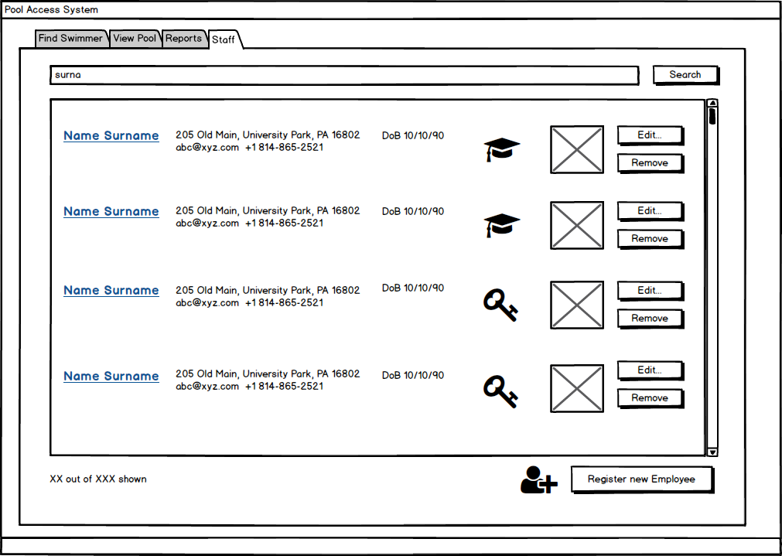

### New Employee screen:

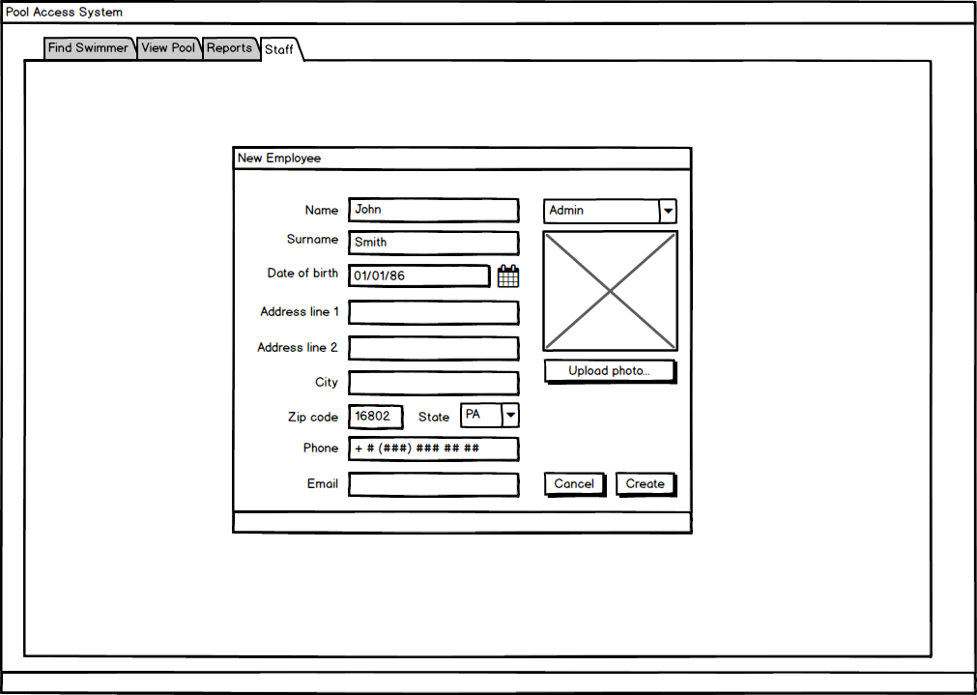

The “New Employee Screen” allows any Admin users create a new employee for the application. The Role dropdown on the top right signifies the Admin or Operator role that the user will have. This is editable later, but it determines what the newly created employee can and cannot do. The employee ID is automatically generated with the surname + first 2 characters of first name. The password is also entered on this screen. Both of these makes up the employee’s credential, which they can use to log in afterwards.

### Update Employee screen:

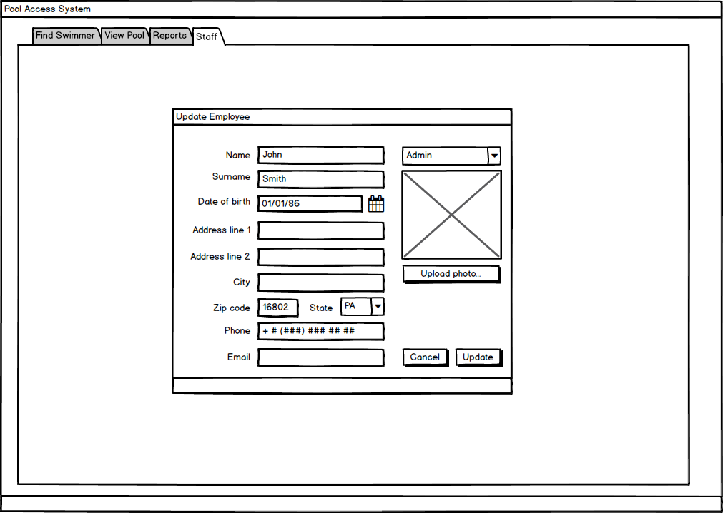

The “Update Employee” screen is also only accessible by Admin users, and it presents the same information as the “New Employee” screen, but in an editable state.